What is Component? Slide 3

A **Business Component** is a reusable unit comprising one or more steps that perform a specific task. Components are the building blocks of business process testing

Business component example Slide 4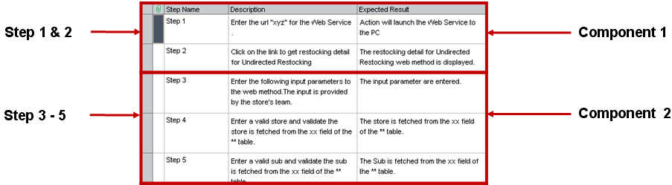

Component with manual content slide 5

Use the Manual Implementation tab in the Business Components module to create or modify manual business component content in the form of manual steps and expected results.

Manual steps represent operations that should be performed on your application when you run the component in a business process test or flow. Each step comprises a step name, a textual description of the procedure to be performed on the application, and the expected result (if any), of performing that step. When a business process test or flow with a manual component runs in ALM, the tester performs the steps defined in the manual component.

Business Component module Slide 6

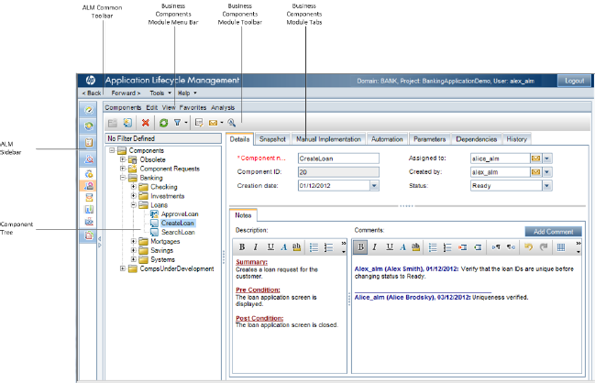

Steps to create a BPT slide 7 and 8 8

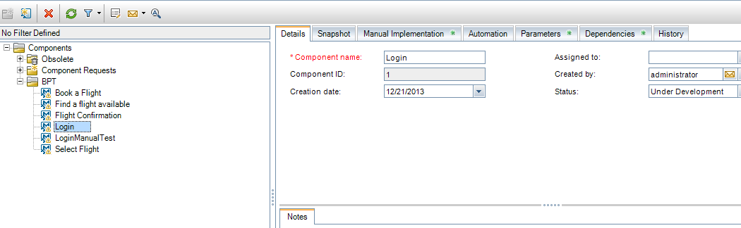

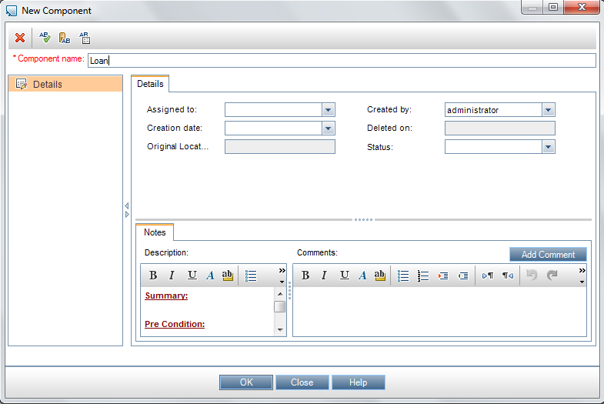

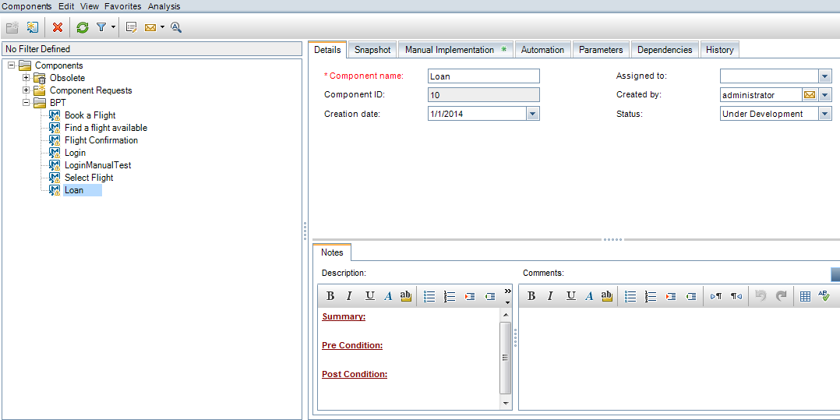

Manual Implementation a BPT component Slide 11

Steps represent operations that should be performed on your application when you run the component in a business process test or flow. Each step comprises a step name, a textual description of the procedure to be performed on the application, and the expected result (if any), of performing that step. When a business process test or flow runs in ALM, the manual steps defined in the component are performed.

How to work with manual components

1. Add steps Slide 13

A step is a detailed operation to be performed on an application as part of testing the business process. Each step includes a description of an action and the expected results. You add steps In the Manual Implementation tab. If there are existing steps, select the step below which you want to add a new step

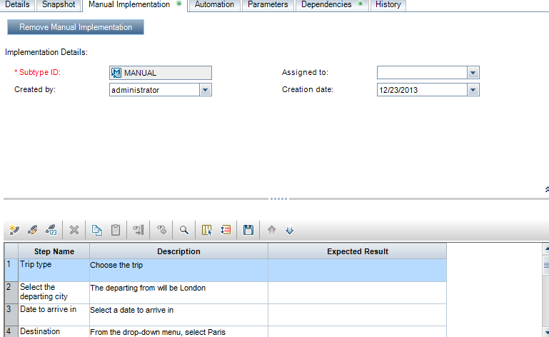

1. **Parameterize steps - optional** Slide 14 and 15

You can insert parameters into a step's description and expected results.

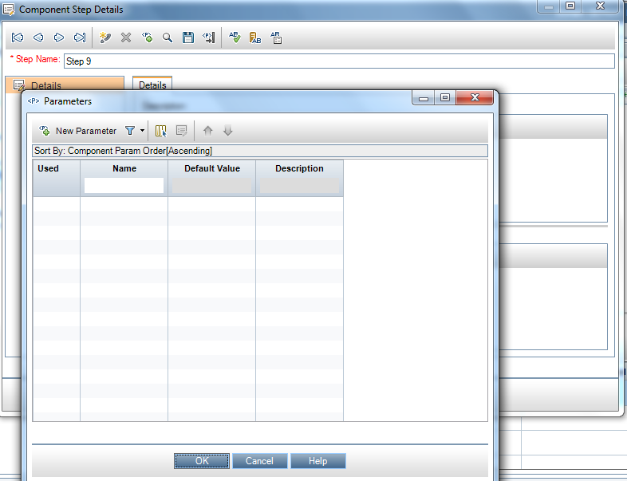

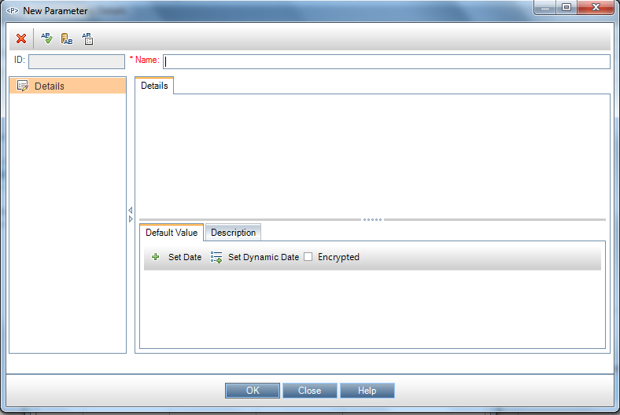

1. Export steps Slide 16

From the Manual Implementation tab, you can export the step information to several formats, including text file, Microsoft Word document, Microsoft Excel spreadsheet, or HTML document.

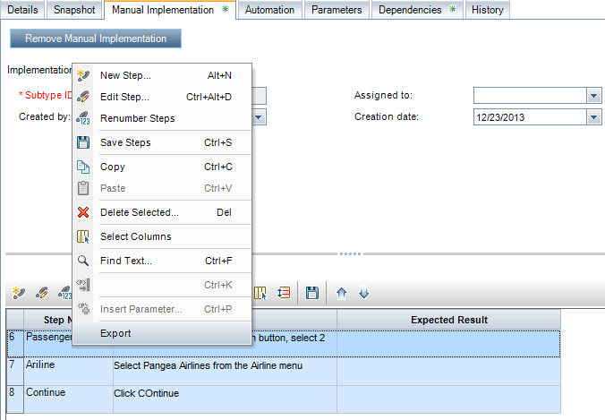

Convert manual tests

